
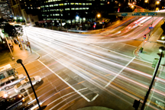
April 2009
DATA  ANALYSIS  SOLUTIONS

Peak Period Validation for WFRC/MAG Model

Report to WFRC and MAG
Table of Contents
1.0 Executive Summary 1
2.0 Review of Model V6.0 1
2.1 Volume Averages by Time-of-Day 1
3.0 Commercial Trips Calibration 2
4.0 External Trips Calibration 3
5.0 HBW, HBO and NHB Trips 5
6.0 Model V6.1 Calibration Results 8
List of Figures

Figure 1: Average Difference over Entire Day (Volumes - Counts) 1
Figure 2: Average Difference by Time-of-Day (Freeways) 2
Figure 3: Average Difference by Time-of-Day (Arterials) 2
Figure 4: Time-of-Day Distribution for Commercial Vehicles (source: FHWA QRFM) 3
Figure 5: Recommended Changes to the Commercial Vehicle Time-of-Day Distributions 3
Figure 6: Model Calibration by Time-of-Day at Externals 4
Figure 7: Counts by Time-of-Day at Externals 4
Figure 8: Recommended Changes to the External Time-of-Day Distributions 5
Figure 9: Time-of-Day Distributions Comparison for HBO trips 6
Figure 10: Time-of-Day Distributions Comparison for HBW trips 6
Figure 11: Time-of-Day Distributions Comparison for NHB trips 7
Figure 12: Recommended Changes to the Trip Purpose Time-of-Day Distributions 7
Figure 13: Proposed Time-of-Day Assumptions for Model V6.1 8
Figure 14: Model Validation Summary for Current Model V6.0 10
Figure 15: Model Calibration Summary for Model V6.0 With Adjusted Parameters 10
Figure 16: Percentage Error of Model Volume on All Roadways 11
Figure 17: Percentage Error of Model Volume on Freeways 11
Figure 18: Percentage Error of Model Volume on Arterials 12

Executive Summary
WFRC asked RSG to assess the calibration of the regional travel model against peak period traffic count data. Historically the WFRC/MAG model has been calibrated to daily traffic counts and this effort is intended to ensure that the model forecasts reasonable volumes during specific time periods, which is how the results are often used for corridor studies. RSG approached this problem in three steps:
- The peak period traffic volumes from the base year (2005) model (V6.0) were compared to average weekday traffic counts for the four time periods in the model.
- The assumptions in the model that identify the percentage of person trips in each time period (by trip purpose) were compared to National Household Travel Survey (NHTS) data and to data from FHWA’s Quick Response Freight Manual.
- The time-of-day assumptions in the model were modified to be more consistent with the NHTS survey data and so that the model more closely matched traffic counts by time-of-day.
This analysis was conducted for the four time periods in the WFRC/MAG model, which are the morning peak (AM), the midday (MD), the PM peak (PM) and nighttime (EV). The four peak periods are defined as follow:
  - AM: 6:00 AM to 9:00 PM
  - MD: 9:00 AM to 3:00 PM
  - PM: 3:00 PM to 6:00 PM
  - EV: 6:00 PM to 6:00 AM
Time-of-day assumptions were adjusted for every trip purpose in the model, including commercial and external trips, so model volumes would more closely match assigned traffic counts for both freeways and surface roads. Thirty different model runs were made with different time-of-day assumptions.
The new model matched the observed data target well on all roadways, with the lone exception of arterials in the AM.

Review of Model V6.0

Volume Averages by Time-of-Day
RSG compared observed and modeled average traffic volumes for arterials and freeway facilities for each of the four time periods in the model. Model volumes were extracted where observed count data existed on the highway network. Observed data came from UDOT and is reported in average annual daily traffic. This data was converted to an average weekday volume to match modeled volumes.

Figure 1: Average Difference over Entire Day (Volumes - Counts)
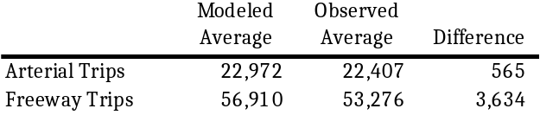

Figure 2: Average Difference by Time-of-Day (Freeways)
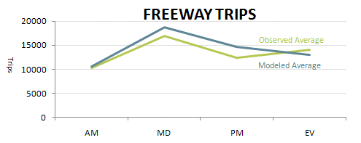

Figure 3: Average Difference by Time-of-Day (Arterials)
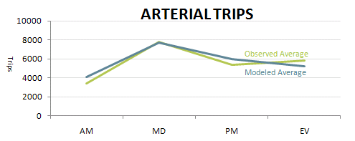
shows that the modeled average of freeway trips is similar to the observed average in the AM peak, is greater than the observed average during the midday and early evening, and is less than the observed average at night. Figure 3 shows that the modeled average of arterial trips is greater than the observed average during the morning and early evening, similar to the observed average in the midday, and less than the observed average at night. These results suggest that the model has a tendency to overestimate traffic during periods of higher volume—the morning through the early evening—and underestimate traffic during periods of lower volume—at night.

Commercial Trips Calibration
Commercial trip distribution in the model was modified according to the Quick Response Freight Manual. The temporal distribution table in Figure 4 was used to calculate an initial diurnal distribution for the commercial trip purpose in the model. The initial split was calculated by summing the individual hour percentages that make up each time period for the Four-Tire, Single Unit, and Combinations categories. The category percentages were then averaged together. Initial changes made in Commercial trips distribution is listed in Figure 5.

Figure 4: Time-of-Day Distribution for Commercial Vehicles (source: FHWA QRFM)
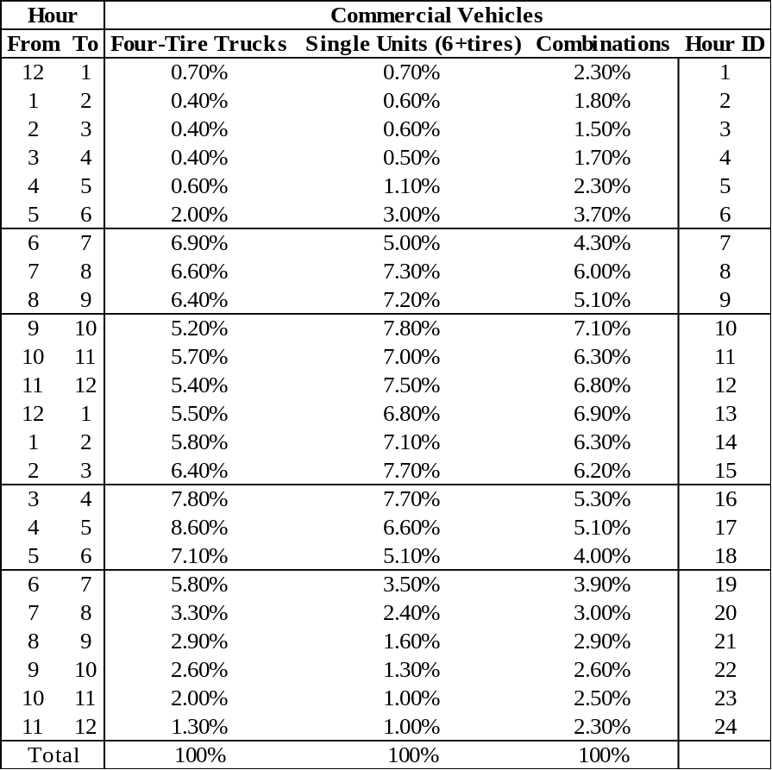

Figure 5: Recommended Changes to the Commercial Vehicle Time-of-Day Distributions
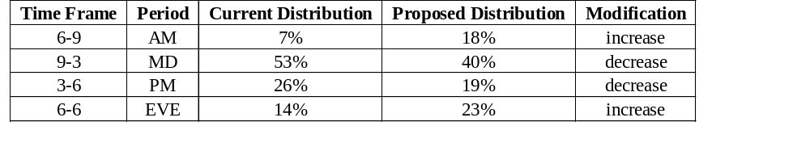

External Trips Calibration
Model link volumes were compared with traffic counts data taken from two stations along I-80. These data were used to develop the directional split to initially compare against model values. The comparison showed that modeled volumes were significantly higher than observed data for AM travel inbound and PM travel outbound, whereas modeled volumes were relatively high for MD travel both inbound and outbound, as seen in Figure 6.

Figure 6: Model Calibration by Time-of-Day at Externals
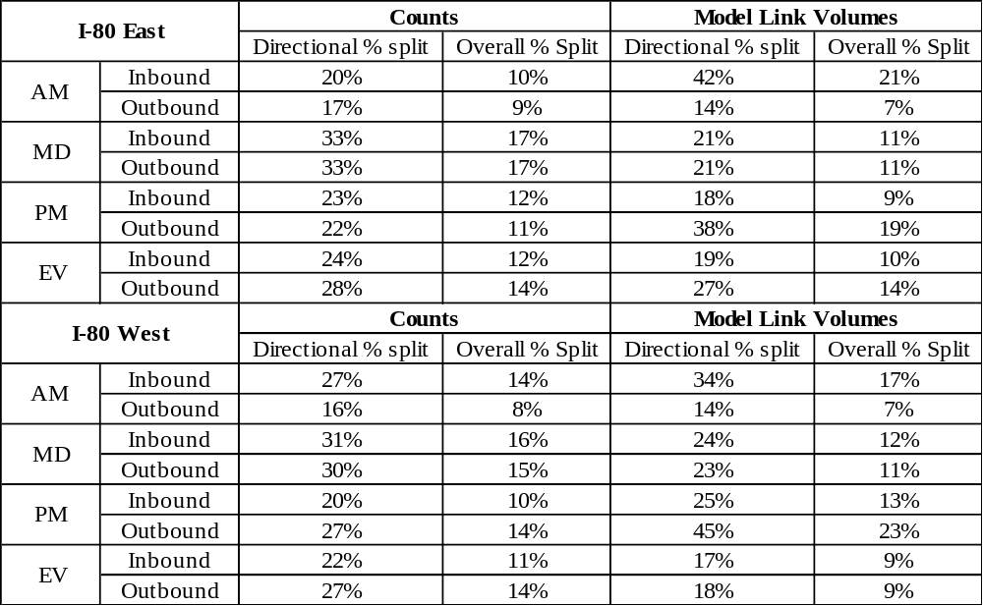
After the initial comparison was performed, subsequent data was obtained from UDOT’s 2008 UDOT ATR reports. This data included the two I-80 stations from and two additional external stations for I-15. These data were used to pivot and modify the previous comparison in order to derive the proposed set of external peak period distribution values used in the initial testing. These count data are shown in Figure 7.

Figure 7: Counts by Time-of-Day at Externals
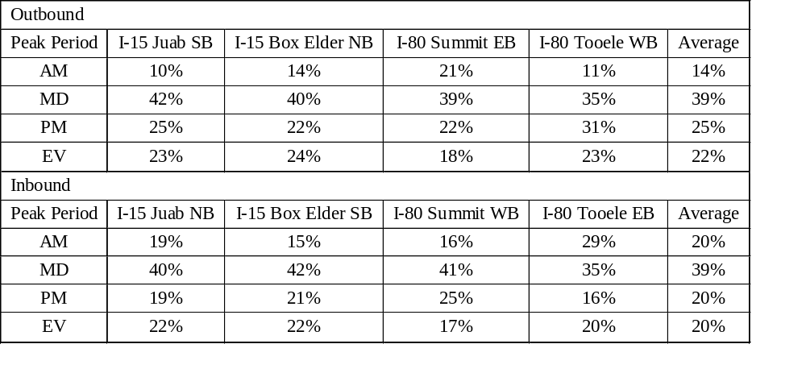
Figure 8 shows the initial adjustments to the time-of-day distribution for external trips. RSG calculated the average percentage in each peak period in each direction and separated IX and XI trips based on the observed time-of-day distribution pattern.

Figure 8: Recommended Changes to the External Time-of-Day Distributions
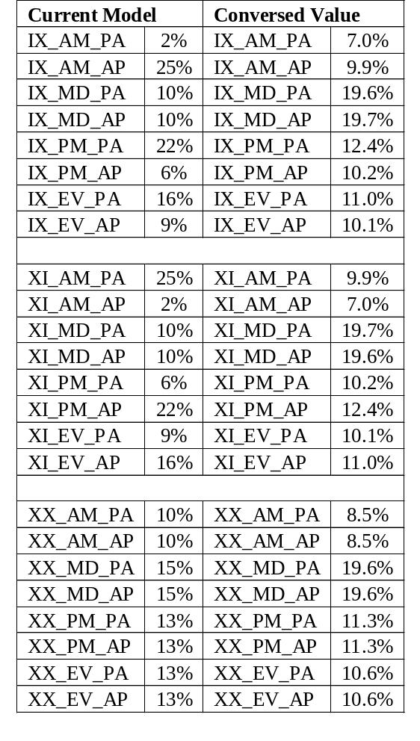

HBW, HBO and NHB Trips
RSG compared Home Based Work (HBW), Home Based Other (HBO) and None Home Based (NHB) model trips to NHTS data. All the results are shown in Figures 9 through 11.
The comparison suggests that the model distributes too many HBO trips in AM period and insufficient trips during mid day. The HBW trips in AM period may also be overestimated. For NHB trips, trips in PM peak appear to be overestimated and volumes at night are underestimated.
Based on this data, modifications were made to the HBW, HBO, & NHB distribution period splits parameters shown in Figure 12 as the starting point to calibration for these purposes.

Figure 9: Time-of-Day Distributions Comparison for HBO trips
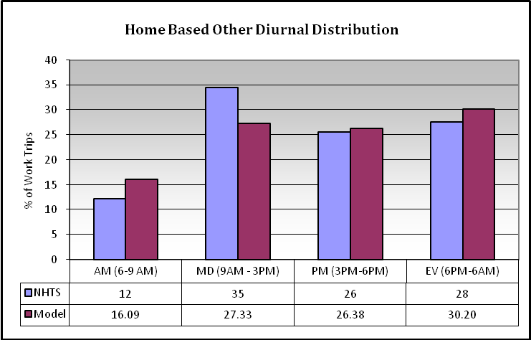

Figure 10: Time-of-Day Distributions Comparison for HBW trips
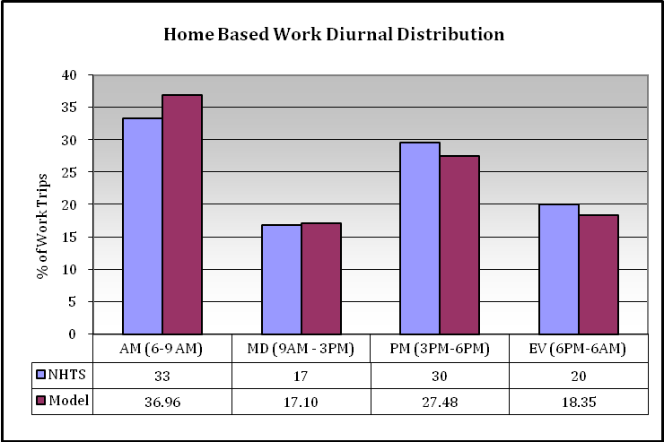

Figure 11: Time-of-Day Distributions Comparison for NHB trips
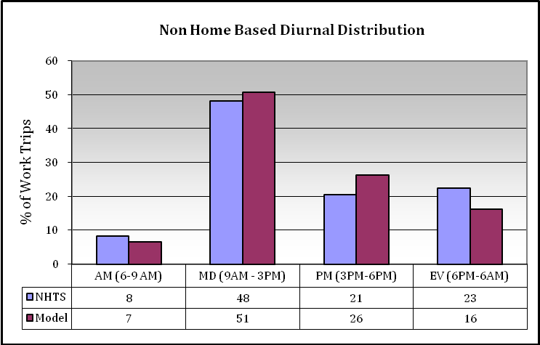

Figure 12: Recommended Changes to the Trip Purpose Time-of-Day Distributions
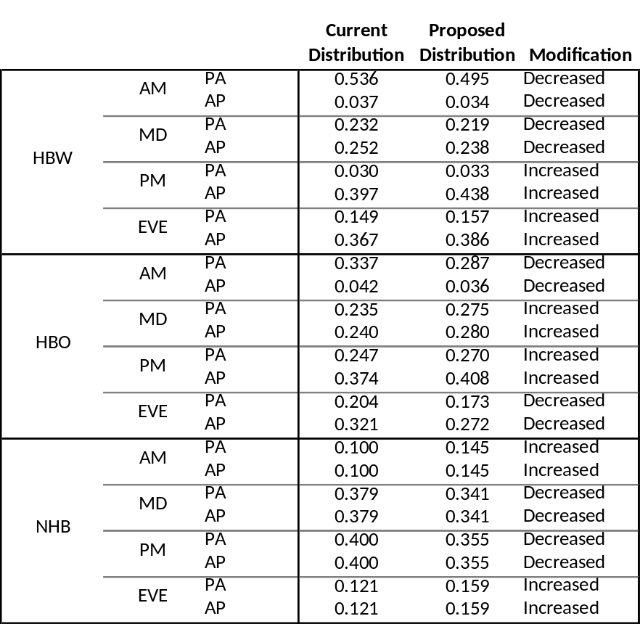

Model V6.1 Calibration Results
After multiple model runs based on initial changes, RSG made further adjustments on proposed time-of-day assumptions to improve the quality of model. After 30 testing model runs, RSG reached an optimized result, which matched trip distribution pattern with traffic count data quite well. Figure 13 shows all the changes in the resulting model scripts.

Figure 13: Proposed Time-of-Day Assumptions for Model V6.1
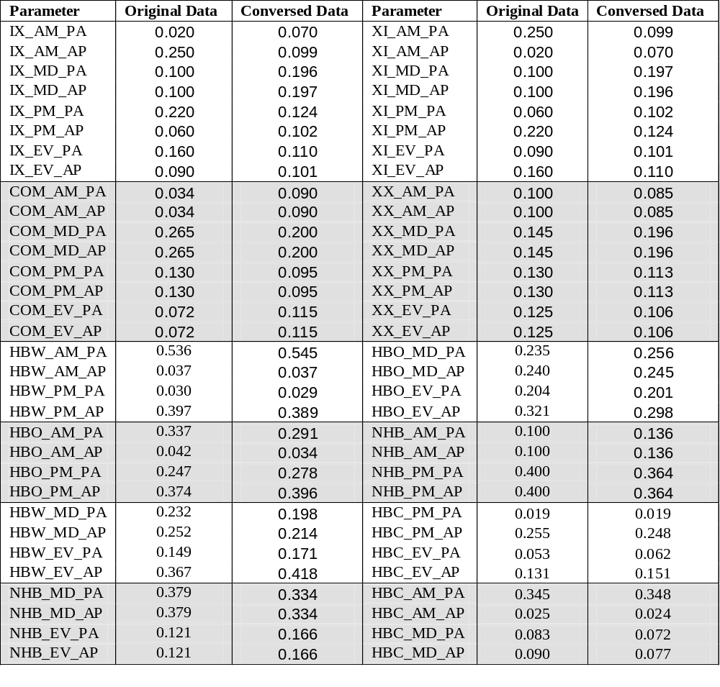
In the process of model testing, results of each model run were recorded and compared with traffic count data. Volume difference and percentage error were used to describe the quality of the model.
Volume difference here means the difference between modeled volume and traffic count data. Volume percentage error equals volume difference divided by traffic count data. The relationship between volume difference and volume percentage error is presented in Equation 1.
(1)
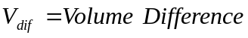
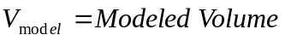
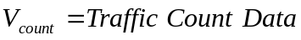
Besides 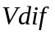 and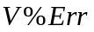, difference and percentage error of the percentages of volumes by time-of-day were also calculated to see whether or not traffic distribution was balanced in the whole day. The relationship between 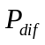 and 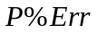 is presented in Equation 2.
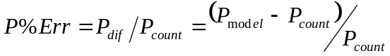 (2)
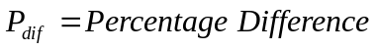
Figures 14 through 18 present validation results of the current model and the model with the new peak period percentages applied. The adjusted model performs better than the previous model in almost all cases. The notable exception was the AM peak where the new model has a higher percentage error for both arterials and freeways.

Figure 14: Model Validation Summary for Current Model V6.0
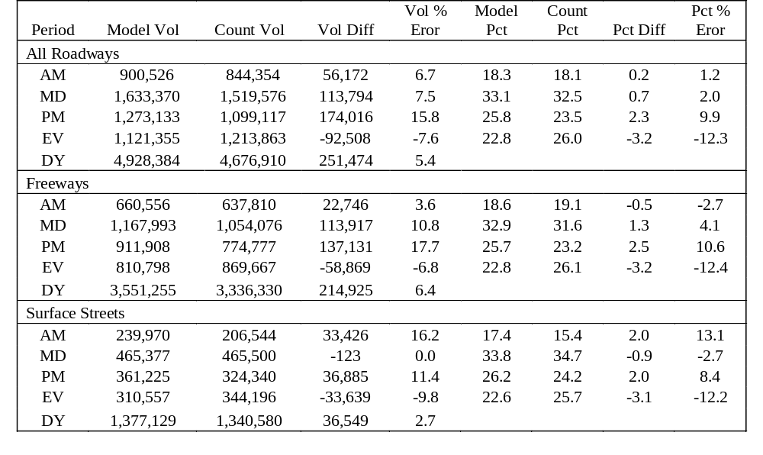

Figure 15: Model Calibration Summary for Model V6.0 With Adjusted Parameters
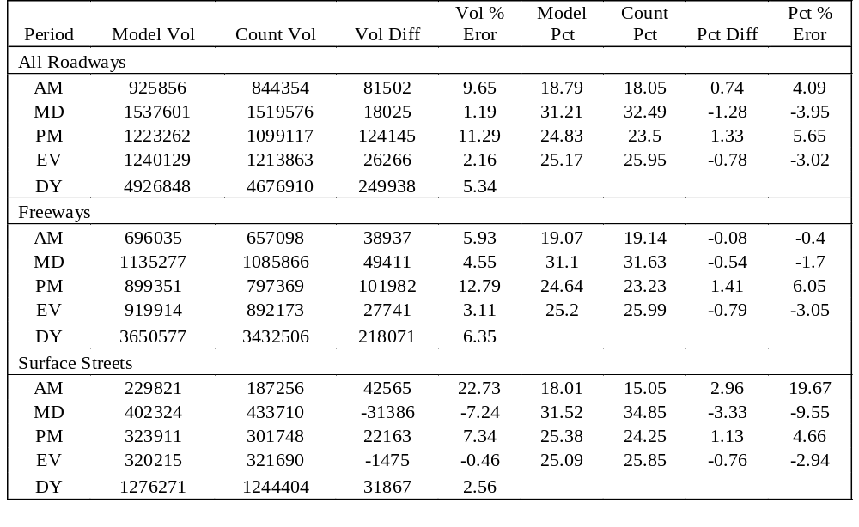

Figure 16: Percentage Error of Model Volume on All Roadways
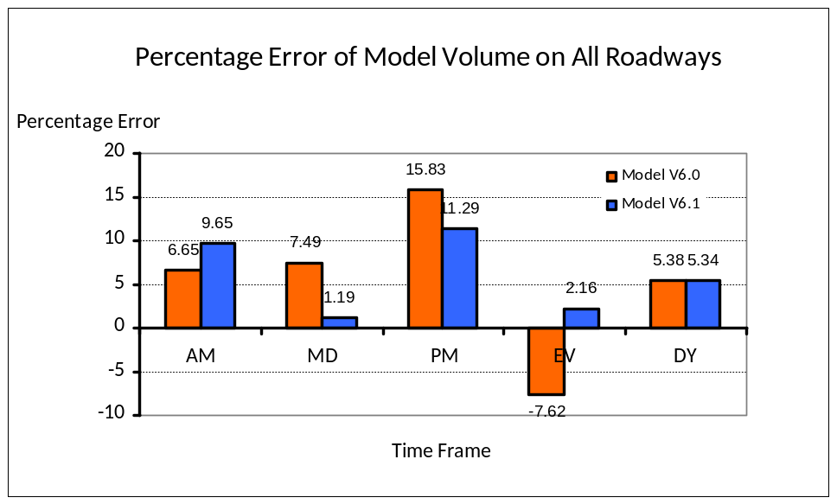

Figure 17: Percentage Error of Model Volume on Freeways
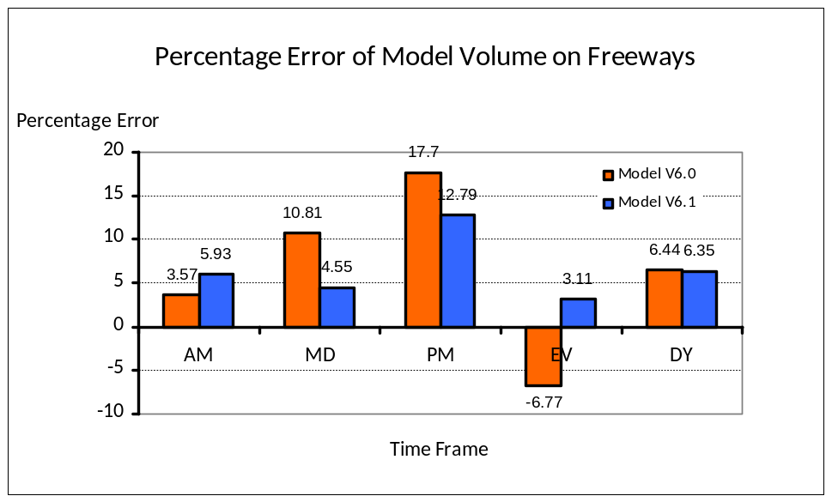

Figure 18: Percentage Error of Model Volume on Arterials
